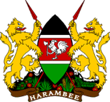 MOMBASA COUNTY PUBLIC SERVICE BOARD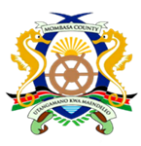

REGISTER OF ISSUANCE AND RECEIPT OF THE WEALTH DECLARATION FORMS.

S/No. | Officer’s Name | Officer’s Personal Number | Department or Unit | Designation | Type of Declaration | Date and Signature of Officer Receiving the Form | Date and Signature of Officer Receiving the Duly filled Declaration Form | Remarks (If Any)

